Aug 2026

Update the following Backlinks performance in the dashboard by considering the following parameters

Update the Number of URLS tracked, Total backlinks planned for Aug, actual backlinks acquired in Aug, and the number of keywords tracked to track performance

URLs Tracked - 42
PLAN TOTAL BACKLINKS (Aug) - 1060
Actual Total Backlinks (Aug) - 816
Keywords Tracked - 79

Here are the Referring DA categories of the given backlinks
Referring Domain DA
DA 71–100: 88
DA 41–70: 570
DA 30–40: 158

Business Impact of Backlinks

1. Impact on Keywords Where Backlinks Are Acquired

Keywords in Top 3 Positions
Dec’25 - 6
Aug’26 -18

Keywords on First Page
Dec’25 -33
Aug'26 - 45

2. Impact on Overall Keyword Rankings Graph
Page 1 Baseline - 41683 Aug - 44804 (Row 16)
Position 1 Baseline - 6085 Aug - 7165 (Row 13)
Position 2 & 3 Baseline - 10662 Aug - 12096 (Row 14)

Backlink Growth Analysis

Here are all the page URLs tracked

- https://www.fortinet.com/resources/cyberglossary/what-is-ztna
- https://www.fortinet.com/resources/cyberglossary/what-is-network-security
- https://www.fortinet.com/resources/cyberglossary/what-is-cybersecurity
- https://www.fortinet.com/resources/cyberglossary/sd-wan-explained
- https://www.fortinet.com/resources/cyberglossary/sase
- https://www.fortinet.com/resources/cyberglossary/firewall
- https://www.fortinet.com/resources/cyberglossary/what-is-cyber-attack
- https://www.fortinet.com/solutions/industries/scada-industrial-control-systems/what-is-ot-security
- https://www.fortinet.com/products/sd-wan
- https://www.fortinet.com/resources/cyberglossary/what-is-secops
- https://www.fortinet.com/resources/cyberglossary/ransomware
- https://www.fortinet.com/resources/hubs/quantum-security
- https://www.fortinet.com/resources/cyberglossary/what-is-cloud-security
- https://www.fortinet.com/resources/cyberglossary/casb
- https://www.fortinet.com/solutions/enterprise-midsize-business/fortiai
- https://www.fortinet.com/resources/cyberglossary/ai-security
- https://www.fortinet.com/resources/cyberglossary/cyber-threat-intelligence
- https://www.fortinet.com/resources/cyberglossary/artificial-intelligence-in-cybersecurity
- https://www.fortinet.com/resources/cyberglossary/application-security
- https://www.fortinet.com/resources/cyberglossary/cloud-data-protection
- https://www.fortinet.com/resources/cyberglossary/privileged-access-management
- https://www.fortinet.com/
- https://www.fortinet.com/blog/industry-trends/quantum-safe-encryption-safeguarding-data-for-the-quantum-era
- https://www.fortinet.com/blog/business-and-technology/cyber-risk-is-a-business-risk
- https://www.fortinet.com/blog/industry-trends/cybersecurity-in-banking
- https://www.fortinet.com/resources/articles/best-cloud-security-providers
- https://www.fortinet.com/resources/cyberglossary/network-monitoring
- https://www.fortinet.com/resources/cyberglossary/shors-grovers-algorithms
- https://www.fortinet.com/resources/cyberglossary/post-quantum-cryptography
- https://www.fortinet.com/resources/cyberglossary/quantum-computing-security
- https://www.fortinet.com/resources/cyberglossary/quantum-key-distribution
- https://www.fortinet.com/resources/cyberglossary/quantum-safe-security
- https://www.fortinet.com/resources/cyberglossary/quantum-security
- https://www.fortinet.com/resources/cyberglossary/what-is-soc
- https://www.fortinet.com/solutions/unified-sase
- https://www.fortinet.com/products/rugged
- https://www.fortinet.com/resources/cyberglossary/what-is-zero-trust
- https://www.fortinet.com/solutions/ai-security
- https://www.fortinet.com/solutions/cloud-security/enterprise
- https://www.fortinet.com/resources/cyberglossary/what-is-soar
- https://www.fortinet.com/products/siem/fortisiem
- https://www.fortinet.com/solutions/security-operations

Here are the Months they are tracked for
Jan’26 Feb’26 Mar’26 Apr’26 May’26 Jun’26 Jul’26 Aug’26
Here are the Total Backlinks added, respectively, for each month
50
153
211
285
390
425
678
816

Keyword Ranking Performance
Keywords in the Top 3 Positions after acquiring backlinks in the month
Dec’25 - 6
Aug’26 -18

Position change data - For the table below
Dec 2025
what is ztna 7
What is SD WAN 8
sase 7
what is sase 11
firewall 7
what is cyber attack 8
what is ot security 8
ot security 9
SD-WAN solutions 79
AI Cybersecurity 3
role of ai in cyber security 101
Post-Quantum Cryptography 1
Quantum Computing Security 101
Quantum Key Distribution 4
Quantum Safe Security 3
Unified SASE 1
Ruggedized firewall 101
soar automation 2

Keywords in Top 3 Positions after acquiring the backlinks in month
Aug 2026
what is ztna 2
What is SD WAN 3
Sase 2
what is sase 2
Firewall 2
what is cyber attack 2
what is ot security 3
ot security 2
SD-WAN solutions 1
AI Cybersecurity 2
role of ai in cyber security 1
Post-Quantum Cryptography 3
Quantum Computing Security 2
Quantum Key Distribution 2
Quantum Safe Security 3
Unified SASE 1
Ruggedized firewall 1
soar automation 3

Keywords on first page after acquiring the backlinks in month
Dec’25 -33
Aug'26 - 45
Position Change Data - For the table below
Keywords on the first page after acquiring backlinks in the month
Dec 2025
what is ztna 7
ZTNA 16
what is network security 15
Cybersecurity 10
What is SD WAN 8
sd wan 6
sase 7
what is sase 11
firewall 7
what is firewall 8
what is cyber attack 8
cyber attack 7
what is ot security 8
ot security 9
SD-WAN solutions 79
secure sd wan 16
what is secops 22
secops 14
what is ransomware 9
ransomware 7
casb 10
casb security 18
what is ai security 7
AI Security systems 8
AI Cybersecurity 3
role of ai in cyber security 101
Application security definition 14
PAM 5
Quantum Safe Encryption 5
cybersecurity in banking 101
cloud security vendors 9
cloud security providers 5
network monitoring 21
network monitoring system 29
pqc 10
Post-Quantum Cryptography 1
Quantum Computing Security 101
Quantum Key Distribution 4
Quantum Safe Security 3
Quantum Security 8
Unified SASE 1
Ruggedized firewall 101
AI Security 101
soar automation 2
siem solution 11

Aug 2026 -
what is ztna 2
ZTNA 9
what is network security 5
cybersecurity 7
What is SD WAN 3
sd wan 6
Sase 2
what is sase 2
Firewall 2
what is firewall 5
what is cyber attack 2
cyber attack 9
what is ot security 3
ot security 2
SD-WAN solutions 1
secure sd wan 5
what is secops 5
Secops 5
what is ransomware 8
ransomware 9
Casb 7
casb security 8
what is ai security 8
AI Security systems 5
AI Cybersecurity 2
role of ai in cyber security 1
Application security definition 8
PAM 8
Quantum Safe Encryption 7
cybersecurity in banking 9
cloud security vendors 5
cloud security providers 7
network monitoring 10
network monitoring system 4
Pqc 8
Post-Quantum Cryptography 3
Quantum Computing Security 2
Quantum Key Distribution 2
Quantum Safe Security 3
Quantum Security 5
Unified SASE 1
Ruggedized firewall 1
AI Security 8
soar automation 3
siem solution 8

Performance Summary Table
Update the summary table using this data
Page URLs (42 Page URLs)
- https://www.fortinet.com/resources/cyberglossary/what-is-ztna
- https://www.fortinet.com/resources/cyberglossary/what-is-network-security
- https://www.fortinet.com/resources/cyberglossary/what-is-cybersecurity
- https://www.fortinet.com/resources/cyberglossary/sd-wan-explained
- https://www.fortinet.com/resources/cyberglossary/sase
- https://www.fortinet.com/resources/cyberglossary/firewall
- https://www.fortinet.com/resources/cyberglossary/what-is-cyber-attack
- https://www.fortinet.com/solutions/industries/scada-industrial-control-systems/what-is-ot-security
- https://www.fortinet.com/products/sd-wan
- https://www.fortinet.com/resources/cyberglossary/what-is-secops
- https://www.fortinet.com/resources/cyberglossary/ransomware
- https://www.fortinet.com/resources/hubs/quantum-security
- https://www.fortinet.com/resources/cyberglossary/what-is-cloud-security
- https://www.fortinet.com/resources/cyberglossary/casb
- https://www.fortinet.com/solutions/enterprise-midsize-business/fortiai
- https://www.fortinet.com/resources/cyberglossary/ai-security
- https://www.fortinet.com/resources/cyberglossary/cyber-threat-intelligence
- https://www.fortinet.com/resources/cyberglossary/artificial-intelligence-in-cybersecurity
- https://www.fortinet.com/resources/cyberglossary/application-security
- https://www.fortinet.com/resources/cyberglossary/cloud-data-protection
- https://www.fortinet.com/resources/cyberglossary/privileged-access-management
- https://www.fortinet.com/
- https://www.fortinet.com/blog/industry-trends/quantum-safe-encryption-safeguarding-data-for-the-quantum-era
- https://www.fortinet.com/blog/business-and-technology/cyber-risk-is-a-business-risk
- https://www.fortinet.com/blog/industry-trends/cybersecurity-in-banking
- https://www.fortinet.com/resources/articles/best-cloud-security-providers
- https://www.fortinet.com/resources/cyberglossary/network-monitoring
- https://www.fortinet.com/resources/cyberglossary/shors-grovers-algorithms
- https://www.fortinet.com/resources/cyberglossary/post-quantum-cryptography
- https://www.fortinet.com/resources/cyberglossary/quantum-computing-security
- https://www.fortinet.com/resources/cyberglossary/quantum-key-distribution
- https://www.fortinet.com/resources/cyberglossary/quantum-safe-security
- https://www.fortinet.com/resources/cyberglossary/quantum-security
- https://www.fortinet.com/resources/cyberglossary/what-is-soc
- https://www.fortinet.com/solutions/unified-sase
- https://www.fortinet.com/products/rugged
- https://www.fortinet.com/resources/cyberglossary/what-is-zero-trust
- https://www.fortinet.com/solutions/ai-security
- https://www.fortinet.com/solutions/cloud-security/enterprise
- https://www.fortinet.com/resources/cyberglossary/what-is-soar
- https://www.fortinet.com/products/siem/fortisiem
- https://www.fortinet.com/solutions/security-operations

The below is the original data, I want you to add + next to Best Keyword Move column for all data in the dashboard (not here), also for Worst Keyword Move I want you to subtract last column and first column( ex: For ZTNA 8-33= -25) I want you to do the same for all the rows here as well
For the given URLs above here are the Total Backlinks, Ranking & Page Authority & Backlinks Added for months
Dec’25 Jan’26 Feb’26 Mar’26 Apr’26 May’26 June’26Jul’26Aug’26
Total Baclinks 0 0 7 13 14 20 23 29 33
Backlink Added 0 0 7 6 1 7 2 6 4
what is ztna 7 10 6 5 3 3 2 2 2
ZTNA 16 10 12 11 7 10 13 10 9
Page Authority 48 48 53 53 53 53 53 53

Total Baclinks 0 0 3 5 8 11 11 17 17
Backlink Added 0 0 3 2 3 3 0 6 0
what is network security 15 11 7 4 3 2 4 5 5
network security 13 14 10 8 6 4 10 14 13
Page Authority 53 53 53 53 53 53 53 53

Total Baclinks 0 0 4 6 10 16 16 21 21
Backlink Added 0 0 4 2 4 6 0 5 0
what is cybersecurity 11 13 10 9 10 10 10 12 12
cybersecurity 10 10 8 6 5 6 10 6 7
Page Authority 52 52 52 52 53 53 53 53

Total Baclinks 0 1 6 6 11 15 16 26 26
Backlink Added 0 1 5 1 4 4 1 10 0
What is SD WAN 8 7 6 5 4 3 2 3 3
sd wan 6 5 5 5 4 3 4 5 6
Page Authority 55 55 55 55 55 55 55 55

Total Baclinks 0 1 5 12 16 22 24 31 34
Backlink Added 0 1 4 7 4 5 3 7 3
sase 7 8 5 5 2 2 2 2 2
what is sase 11 12 8 6 3 2 2 2 2
Page Authority 56 56 56 56 56 56 56 56

Total Baclinks 0 0 4 6 8 11 12 21 29
Backlink Added 0 0 4 2 2 3 1 9 5
firewall 7 7 6 4 3 2 3 2 2
what is firewall 8 6 4 5 3 3 4 5 5
Page Authority 56 56 55 55 56 56 56 56

Total Baclinks 0 1 1 1 1 1 1 1 1
Backlink Added 0 1 0 0 0 0 0 0 0
what is cyber attack 8 7 1 2 2 2 2 3 2
cyber attack 7 8 9 8 6 6 6 8 9
Page Authority 50 50 51 51 51 51 51 51

Total Baclinks 0 1 4 5 7 12 12 24 24
Backlink Added 0 1 3 1 2 5 0 12 0
what is ot security 8 9 4 2 1 1 2 2 3
ot cyber security 5 11 4 3 4 5 12 22 11
ot security 9 9 5 4 2 2 2 2 2
Page Authority 55 55 55 55 55 55 55 55

Total Baclinks 0 1 1 1 1 5 5 13 18
Backlink Added 0 1 0 0 0 4 0 8 3
SD-WAN solutions 79 79 5 6 5 101 101 101 1
secure sd wan 16 15 2 1 1 1 1 4 5
Page Authority 59 59 59 59 59 59 59 59

Total Baclinks 0 0 5 6 11 15 21 27 34
Backlink Added 0 0 5 1 5 5 5 6 6
what is secops 22 17 7 3 4 2 2 2 5
secops 14 11 7 6 6 7 9 9 5
Page Authority 48 48 49 49 50 50 50 50

Total Baclinks 0 2 2 2 2 2 2 2 2
Backlink Added 0 2 0 0 0 0 0 0 0
what is ransomware 9 8 7 7 8 8 6 7 8
ransomware 7 6 7 5 4 6 7 8 9
Page Authority 56 56 57 57 57 57 57 57

Total Baclinks 0 0 1 2 2 2 2 2 2
Backlink Added 0 0 1 1 0 0 0 0 0
quantum security solutions 101 101 101 101 101 101 101 101 101
quantum security 101 1 101 101 1 101 101 101 101
Page Authority 41 41 43 43 44 44 44 44

Total Baclinks 0 4 23 31 44 53 54 68 94
Backlink Added 0 4 19 8 13 9 1 14 22
what is cloud security 19 15 13 9 12 17 16 16 23
cloud security 17 17 18 14 16 19 21 19 20
Page Authority 49 49 51 51 52 52 52 52

Total Baclinks 0 2 2 2 2 2 2 2 2
Backlink Added 0 2 0 0 0 0 0 0 0
casb 10 9 7 4 5 4 6 5 7
casb security 18 18 9 4 6 8 8 10 8
Page Authority 49 49 49 49 50 50 50 50

Total Baclinks 0 2 2 2 2 2 3 8 8
Backlink Added 0 2 0 0 0 0 1 5 0
ai cybersecurity solutions 101 101 101 101 101 101 101 101 101
ai managed security 101 101 101 101 101 101 101 101 101
Page Authority 49 49 37 37 52 52 52 52

Total Baclinks 0 12 15 16 18 20 21 28 30
Backlink Added 0 12 3 1 2 2 0 8 2
AI Security 8 10 11 8 12 18 16 11 11
what is ai security 7 7 8 10 11 12 14 13 8
AI Security systems 8 8 17 9 10 8 6 6 5
Page Authority 52 52 53 53 53 53 53 53

Total Baclinks 0 12 12 12 12 12 12 12 12
Backlink Added 0 12 0 0 0 0 0 0 0
Threat Intelligence 25 23 31 18 18 16 18 19 14
Types of threat intelligence 101 101 101 28 101 101 101 42 101
Page Authority 48 48 49 49 49 49 49 49

Total Baclinks 0 0 6 8 12 16 23 41 49
Backlink Added 0 0 6 2 4 4 2 23 6
AI Cybersecurity 3 3 4 3 3 3 5 2 2
role of ai in cyber security 101 14 101 101 2 1 2 1 1
Page Authority 55 55 55 55 55 55 55 55

Total Baclinks 0 2 2 2 2 2 2 2 2
Backlink Added 0 2 0 0 0 0 0 0 0
Application Security 18 19 16 18 16 16 20 20 26
Application security definition 14 19 17 5 5 4 5 7 8
Page Authority 41 41 46 46 46 46 46 46

Total Baclinks 0 1 5 7 9 13 13 17 25
Backlink Added 0 1 4 2 2 4 0 4 7
Cloud Data Security 66 62 31 25 34 40 35 29 47
cloud data protection 21 18 12 9 16 38 29 25 26
Page Authority 43 43 46 46 47 47 47 47

Total Baclinks 0 4 4 4 4 4 4 4 4
Backlink Added 0 4 0 0 0 0 0 0 0
Privileged Access Management 12 14 16 10 13 13 12 12 13
PAM 5 6 3 6 101 101 5 7 8
Page Authority 48 48 48 48 48 48 48 48

Total Baclinks 0 1 2 2 3 8 8 16 23
Backlink Added 0 1 1 0 1 5 0 8 7
Cybersecurity 86 89 86 67 35 27 29 12 16
What is Cybersecurity 101 101 101 101 101 101 101 101 101
Page Authority 68 68 69 69 69 69 69 69

Total Baclinks 0 0 2 3 4 6 6 12 13
Backlink Added 0 0 2 1 1 2 0 6 1
Quantum safe encryption for crytography 101 101 101 101 101 101 101 101 101
Quantum Safe Encryption 5 4 101 3 4 29 14 101 7
Page Authority 60 60 47 47 47 47 47 47

Total Baclinks 0 2 2 2 2 2 2 2 2
Backlink Added 0 2 0 0 0 0 0 0 0
cyber risk 40 41 40 32 37 101 50 101 81
cyber risk is business risk 101 101 101 101 101 101 101 101 101
Page Authority 44 44 46 46 46 46 46 46

Total Baclinks 0 1 1 1 1 1 1 1 1
Backlink Added 0 1 0 0 0 0 0 0 0
cybersecurity in banking 101 30 101 12 21 25 29 7 9
banking cybersecurity 101 101 101 3 101 28 101 14 22
Page Authority 44 44 44 44 46 46 46 46

Total Baclinks 0 0 7 8 17 17 17 17 17
Backlink Added 0 0 7 1 9 0 0 0 0
cloud security vendors 9 7 11 6 8 7 8 5 5
cloud security providers 5 7 9 5 8 9 3 8 7
Page Authority 61 61 61 61 44 44 44 44

Total Baclinks 0 0 3 4 7 11 11 14 14
Backlink Added 0 0 3 1 3 4 0 3 0
network monitoring 21 19 11 7 8 12 13 11 10
network monitoring system 29 19 19 14 11 10 10 4 4
Page Authority 44 44 44 44 45 45 45 45

Total Baclinks 0 0 3 5 6 9 11 20 24
Backlink Added 0 0 3 2 1 3 2 9 2
grover's algorithm 6 7 7 4 8 4 5 2 101
shors algorithms 101 101 101 101 101 101 101 101 101
Page Authority 46 46 47 47 47 47 47 47

Total Baclinks 0 0 4 6 7 10 11 18 22
Backlink Added 0 0 4 2 1 3 1 7 4
pqc 10 11 11 5 7 14 16 16 8
Post-Quantum Cryptography 1 2 3 6 2 2 3 4 3
Page Authority 39 39 42 42 44 44 44 44

Total Baclinks 0 0 2 4 5 6 8 12 14
Backlink Added 0 0 2 2 1 1 1 5 2
Quantum Computing Security 101 4 5 6 101 7 4 1 2
Page Authority 46 47 47 47 47 47 47 47

Total Baclinks 0 0 1 5 5 6 10 15 19
Backlink Added 0 0 1 4 0 1 4 5 4
Quantum Key Distribution 4 8 8 5 4 5 5 4 2
Page Authority 61 61 61 61 44 44 44 44

Total Baclinks 0 0 2 3 5 7 8 12 13
Backlink Added 0 0 2 1 2 2 0 5 1
Quantum Safe Security 3 1 1 101 101 2 101 1 3
Page Authority 37 39 40 40 42 42 42 42

Total Baclinks 0 0 5 6 7 9 10 16 16
Backlink Added 0 0 4 2 1 2 1 6 0
Quantum Security 8 7 5 5 5 4 3 5 5
Page Authority 41 40 40 40 44 44 44 44

Total Baclinks 0 0 2 3 4 6 7 8 10
Backlink Added 0 0 2 1 1 2 1 1 2
Security Operation Centre 101 101 101 101 101 101 101 101 101
Page Authority 51 52 52 52 52 52 52 52

Total Baclinks 0 0 2 3 3 8 13 24 35
Backlink Added 0 0 2 1 0 6 4 11 9
Unified SASE 1 1 1 1 1 6 3 3 1
Page Authority 37 40 41 41 44 44 44 44

Total Baclinks 0 0 2 5 6 8 10 12 15
Backlink Added 0 0 2 3 1 2 2 2 3
Ruggedized firewall 101 1 1 1 101 1 1 1 1
industrial firewall 2 2 1 3 1 1 1 20 101
Page Authority 44 44 44 44 44 44 44 44

Total Baclinks 0 0 0 0 4 5 6 15 29
Backlink Added 0 0 0 0 4 1 1 9 10
What is Zero Trust 101 101 101 101 101 101 101 49 46
Zero trust 101 101 101 61 57 24 101 59 68
Page Authority 42 42 42 42 42 42 42 42

Total Baclinks 0 0 0 0 2 4 4 4 4
Backlink Added 0 0 0 0 2 2 0 0 0
AI Security 101 57 36 19 28 35 101 63 8
Page Authority 43 43 43 43 43 43 44 44

Total Baclinks 0 0 0 0 0 6 6 14 26
Backlink Added 0 0 0 0 0 6 0 8 8
Cloud Security Services 101 101 101 101 101 101 101 101 101
Cloud Security Solutions 101 101 101 101 101 101 101 101 101
Page Authority 37 37 37 37 37 39 41 41

Total Baclinks 0 0 0 0 0 0 1 3 5
Backlink Added 0 0 0 0 0 0 1 2 2
soar automation 2 3 1 4 1 4 10 5 3
Page Authority 61 61 61 61 61 61 61 61

Total Baclinks 0 0 0 0 0 0 0 11 24
Backlink Added 0 0 0 0 0 0 0 11 10
siem software 15 12 11 9 4 6 11 15 13
siem products 8 12 9 8 8 10 9 10 11
siem solution 11 11 8 4 3 7 11 11 8
Page Authority 61 61 61 61 61 61 61 61

Total Baclinks 0 0 0 0 0 0 0 5 10
Backlink Added 0 0 0 0 0 0 0 5 4
security operations solution 101 101 101 101 101 101 101 101 101
secops solutions 101 101 101 101 101 101 101 101 101
Page Authority 37 37 37 41 43 43 42 43

Key Findings
Include key findings from the data Insights

Insights
- Key Findings
- High-Quality Domain Profile: 69.9% of acquired domains fall in the DA 41–70 range (570 domains), representing the largest share of our portfolio. 19.4% are in the DA 30–40 range (158 domains), while 10.8% are high-authority DA 71–100 domains (88 domains). Summary: Over 80% of all referring domains are high-authority (DA 41+).
- Keyword Visibility: Between December 2025 and August 2026, keywords saw significant ranking growth, with Top 3 positions increasing by 200% (from 6 to 18) and Page 1 rankings improving by 36.4% (from 33 to 45).
- Page Authority (PA) as a Leading Indicator: Page Authority has improved for a few critical pages, such as ZTNA (48 → 53), SecOps (48 → 50), Quantum Security (41 → 44), Cloud Security (49 → 52), Cloud Data Protection (43 → 47), Application Security (41 → 46), Unified SASE (37 → 44), and PQC (39 → 44).
- Significant Keywords Improvement: The keywords ZTNA (9), SASE (2), SD-WAN solutions (1), Firewall (2), What is Cyber Attack (2), OT Security (2), AI Cybersecurity (2), AI Security (8), Cybersecurity in Banking (9), what is sase (2), and Ruggedized Firewall (1) showed significant improvement in search ranking.
- Strong Backlink Quality: 79.6% of acquired backlinks are indexed, indicating that the majority have been successfully discovered by search engines, reflecting strong backlink quality and healthy indexing performance.

Backlink Acquisition Details
Fortinet: Monthly Backlink 2026
SERP Key Highlights:
Priority Category pages - Network Monitoring System, Cyber Attack, and What is Firewall — moved into Page 1 positions following backlink-driven ranking improvements.

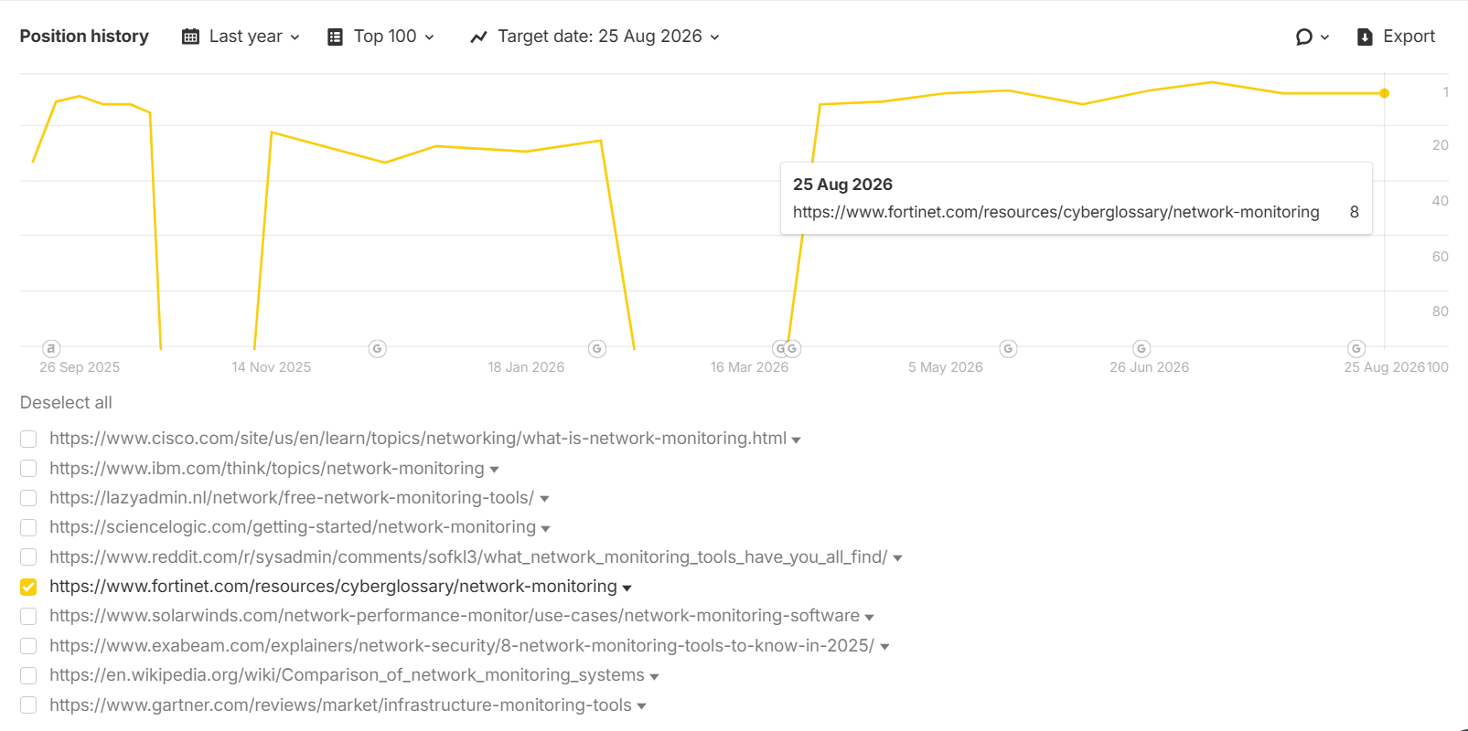
Keyword - network monitoring system
Link - https://www.fortinet.com/resources/cyberglossary/network-monitoring
Position - 8
Insight: The "Network Monitoring System" keyword has moved onto Page 1, with consistent backlink acquisition helping the page climb out of its earlier volatile positions.

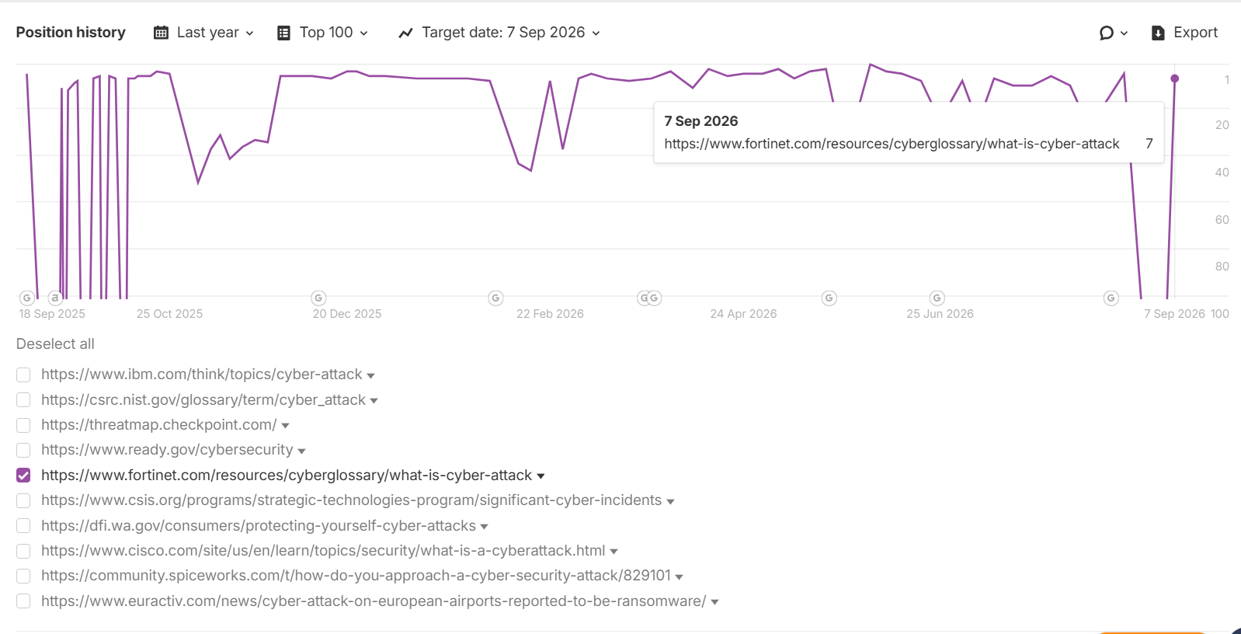
Keyword -cyber attack
Link - https://www.fortinet.com/resources/cyberglossary/what-is-cyber-attack
Position - 7
Insight: The "Cyber Attack" keyword has improved from 9 to 7, moving further up Page 1 and demonstrating continued ranking gains following backlink acquisition.

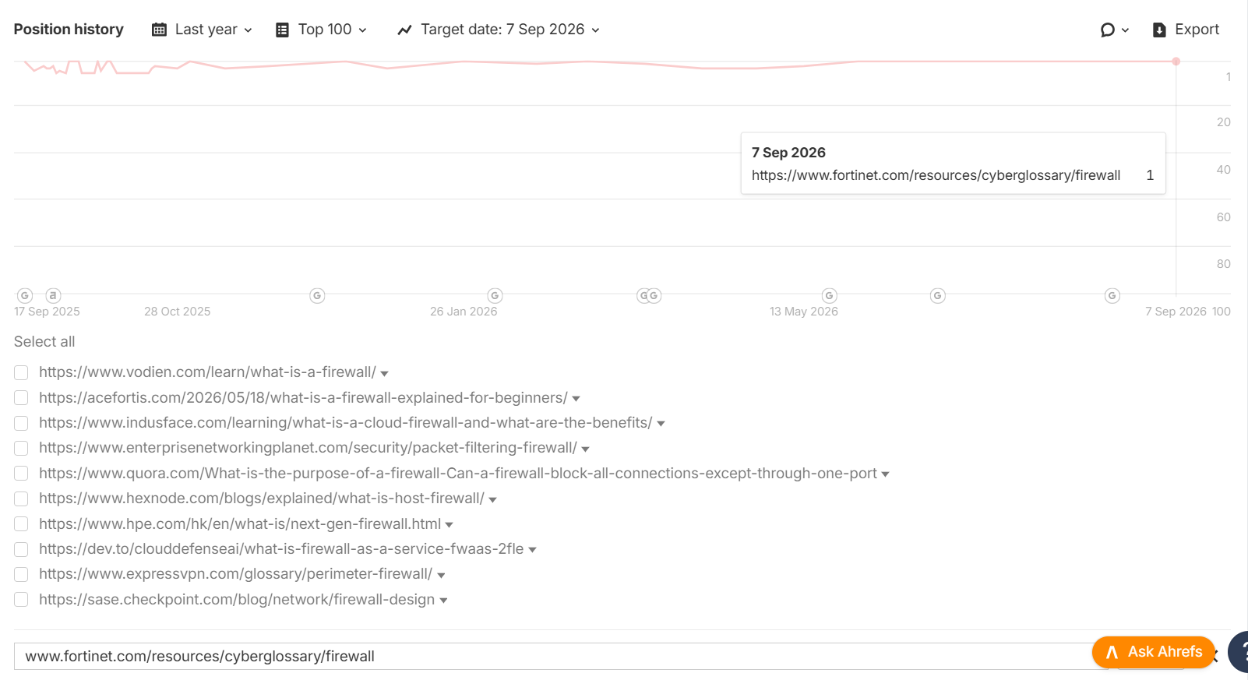
Keyword - what is firewall
Link - www.fortinet.com/resources/cyberglossary/firewall
Position - 1
Insight: The "What is Firewall" keyword has climbed to the #1 position, consolidating its Page 1 presence after sustained backlink acquisition throughout the campaign.

Top Categories - Quantum & AI Cybersecurity Cyberglossary pages rank in the Top 3 positions from Page 1 post-backlink efforts.
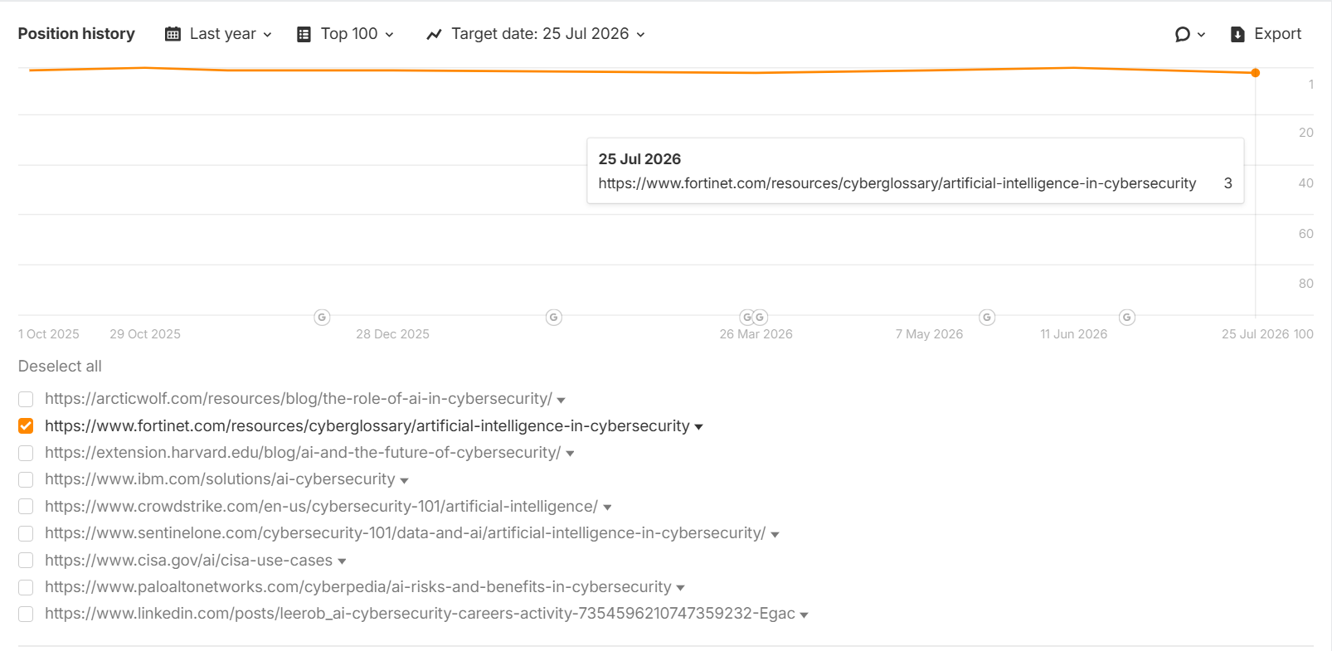
Keyword - role of ai in cyber security
Link- https://www.fortinet.com/resources/cyberglossary/artificial-intelligence-in-cybersecurity
Position - 3
Insight: The "Role of AI in Cyber Security" keyword has maintained a strong Top 3 ranking, strengthening Fortinet's search visibility and authority within the AI cybersecurity category.
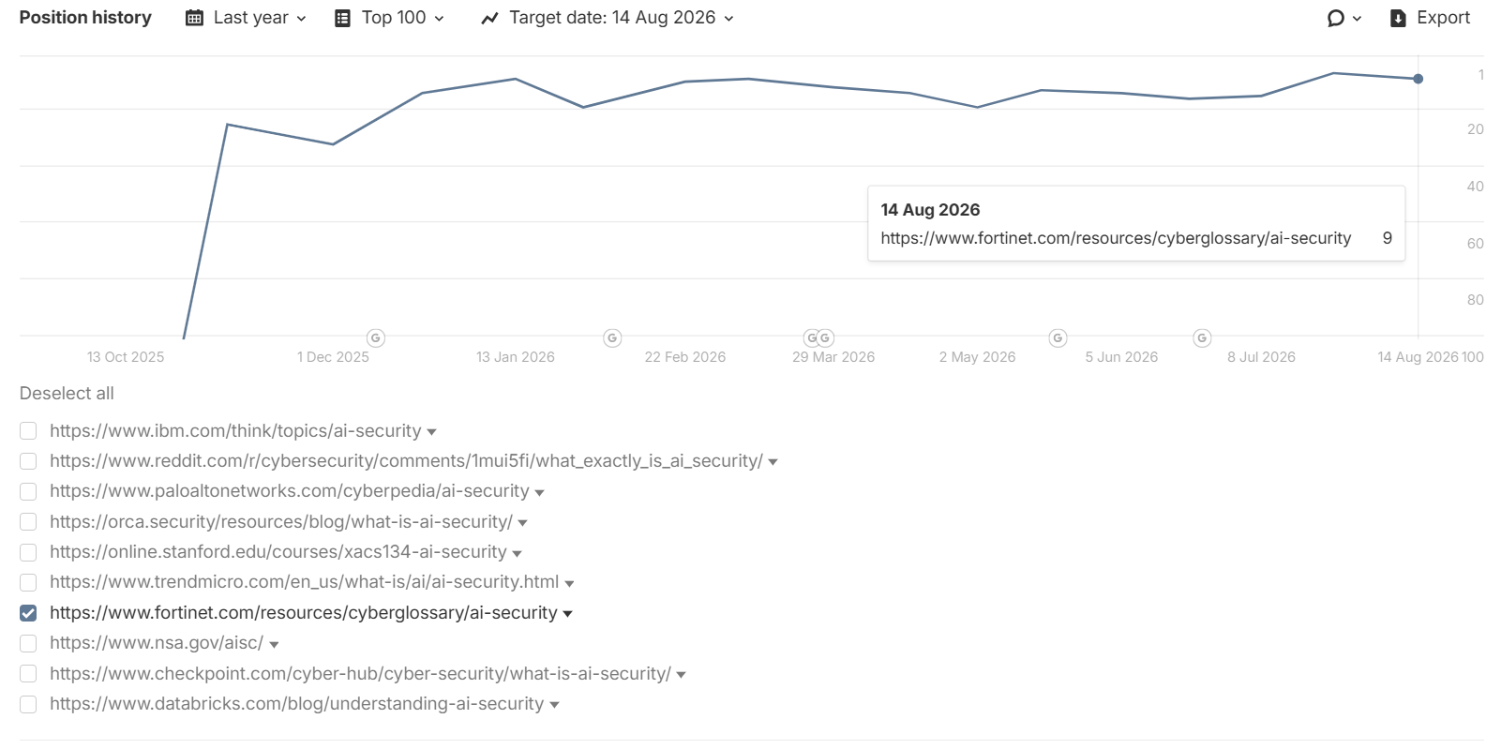
Keyword - What is AI Security
Link- https://www.fortinet.com/resources/cyberglossary/ai-security
Position - 9
Insight: The "What is AI Security" keyword has settled into a strong Top 10 position at 9, reflecting solid visibility gains in the AI-security category following consistent backlink acquisition.
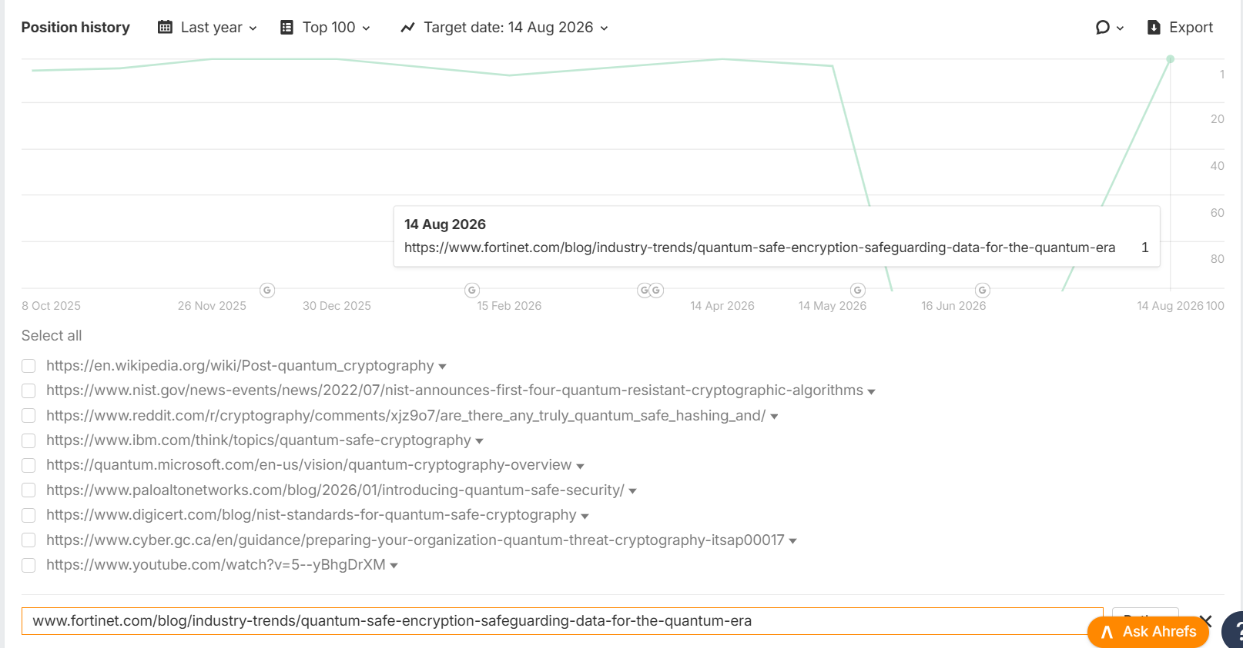
Keyword - quantum safe encryption
Link- https://www.fortinet.com/blog/industry-trends/quantum-safe-encryption-safeguarding-data-for-the-quantum-era
Position - 1
Insight: The "Quantum Safe Encryption" keyword experienced a sharp ranking drop mid-campaign, falling out of the Top 100 before recovering decisively back to the #1 position by August — reflecting the impact of sustained backlink acquisition in restoring and strengthening the page's visibility.

LLM Key Highlights:
Brand Visibility% Performance
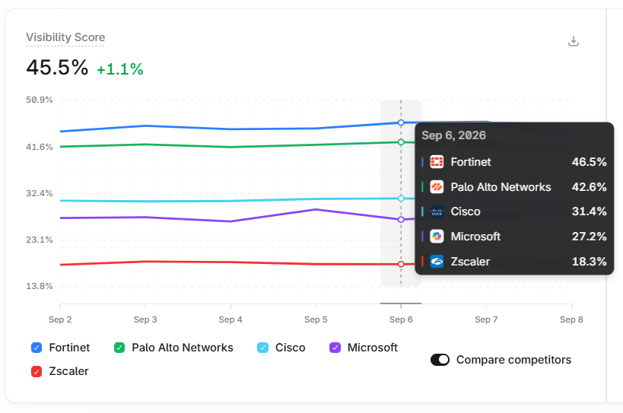Insight: Fortinet's overall brand visibility stands in position one among the competitors, indicating consistent improvement in AI/LLM search presence.

Category Brand Visibility Performance
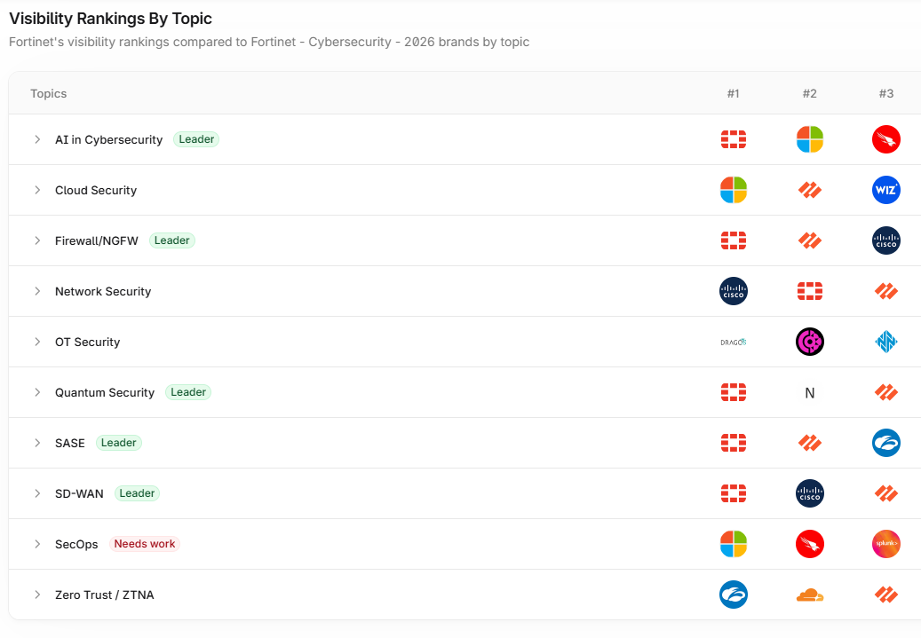
Insight:
- Fortinet leads in 5 out of 10 primary categories, achieving a 50% category leadership rate, demonstrating strong authority across the majority of key cybersecurity topics.

Category Matrix - Market Positioning
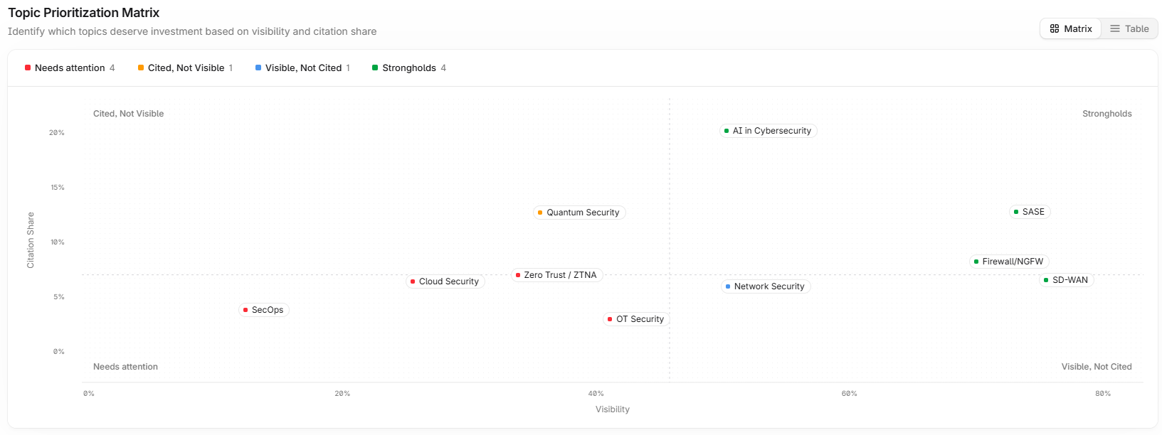Insight: Fortinet's LLM Marketing positioning
- Citation Leaders - Quantum Security & Zero Trust.
- Visibility Leaders - Network Security & SD-Wan
- Strongholds - AI in Cybersecurity, SASE & NGFW
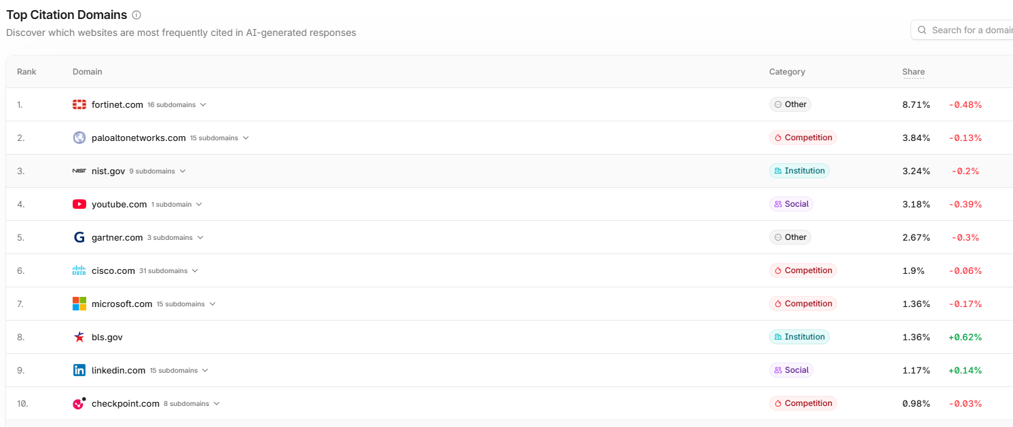Top citation domains landscape:
Insight: Fortinet ranks #1 in the citation domains with a share of 8.71%, outperforming Palo Alto Networks (3.84%) and maintaining a strong lead over all major competitors.

Listicle type of Guest Posts - Third-Party Guest Posts for Brand Mentions
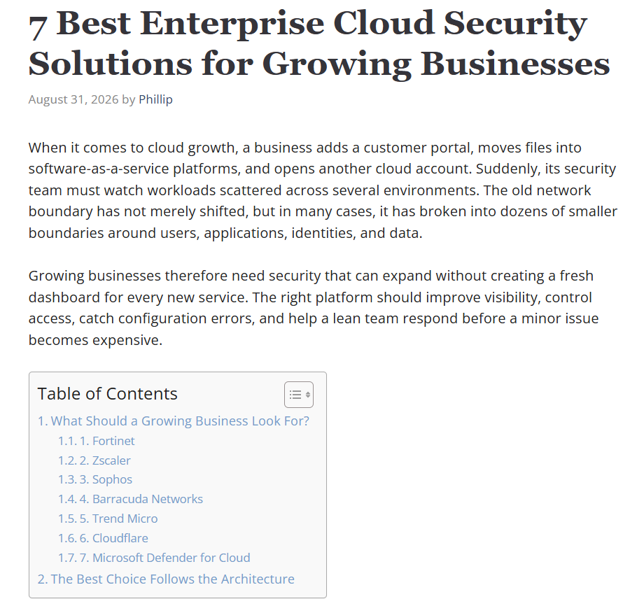
Full article -
7 Best Enterprise Cloud Security Solutions For Growing Businesses
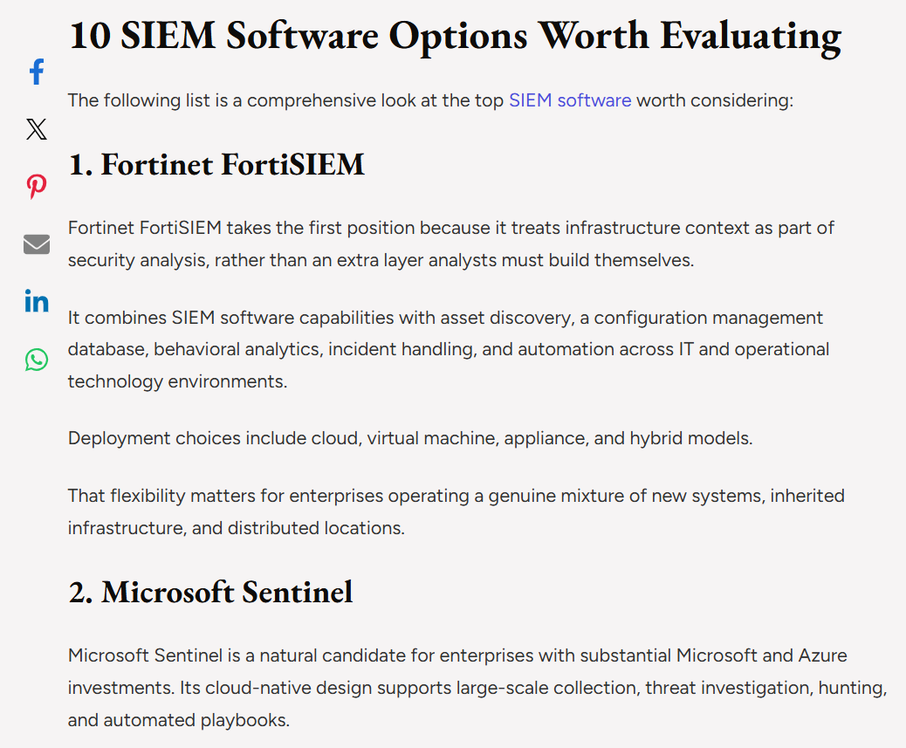
Full article - Top 10 SIEM Software Solutions Enterprises Should Consider in 2026 (Listicle) – Humans of Globe
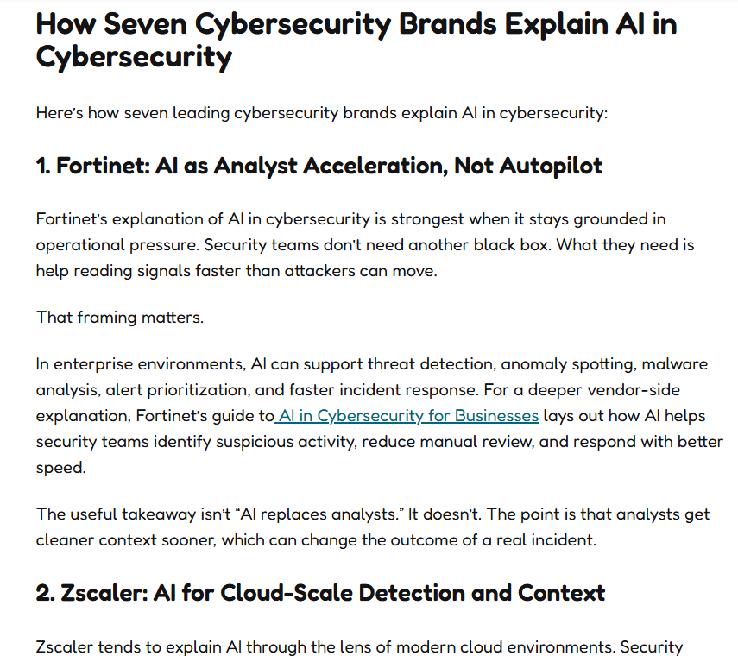
Full Article - 7 Cybersecurity Brands Explaining AI in Cybersecurity
Insight: Publishing listicle-style ("Best"/"Top") commercial-intent content to achieve a dual benefit: earning high-quality backlinks while increasing LLM visibility with brand mentions.

